Name: Lu Anh Thu
ID: 2332300138
Github: https://github.com/thulubbs23-cpu/MIS443-Mock-Test--2332300138
MIS 443 – FINAL EXAMINATION
Finance Analysis with PostgreSQL
Course | MIS 443 | Business Data Management
Duration | 90 minutes | Maximum mark: 100

Dataset Introduction
The dataset represents a retail bank that manages customers, branches, bank accounts, and financial transactions. Managers use the data to analyse customer portfolios, account balances, branch performance, and transaction activity.
- Customers: stores customer names and locations.
- Branches: stores branch names and locations.
- Accounts: stores account ownership, branch assignment, account type, and current balance.
- Transactions: stores the date and amount of each account transaction.
Each account belongs to one customer and one branch, and each account may have multiple transactions. Positive account balances represent funds held by customers; negative Credit Card balances represent amounts owed. Positive transaction amounts are credits, while negative amounts are debits.

Entity–Relationship Diagram
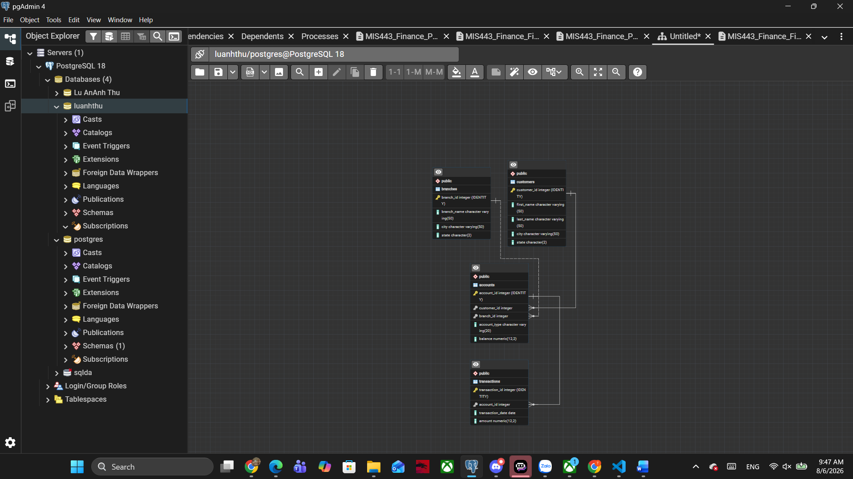

Examination Questions

Question 1 – Database Setup (10 marks)
Create a PostgreSQL database using your full name in lowercase, without spaces or Vietnamese diacritics. Connect to the database and execute MIS443_Finance_PostgreSQL.sql. Confirm that the customers, branches, accounts, and transactions tables are available in the public schema.
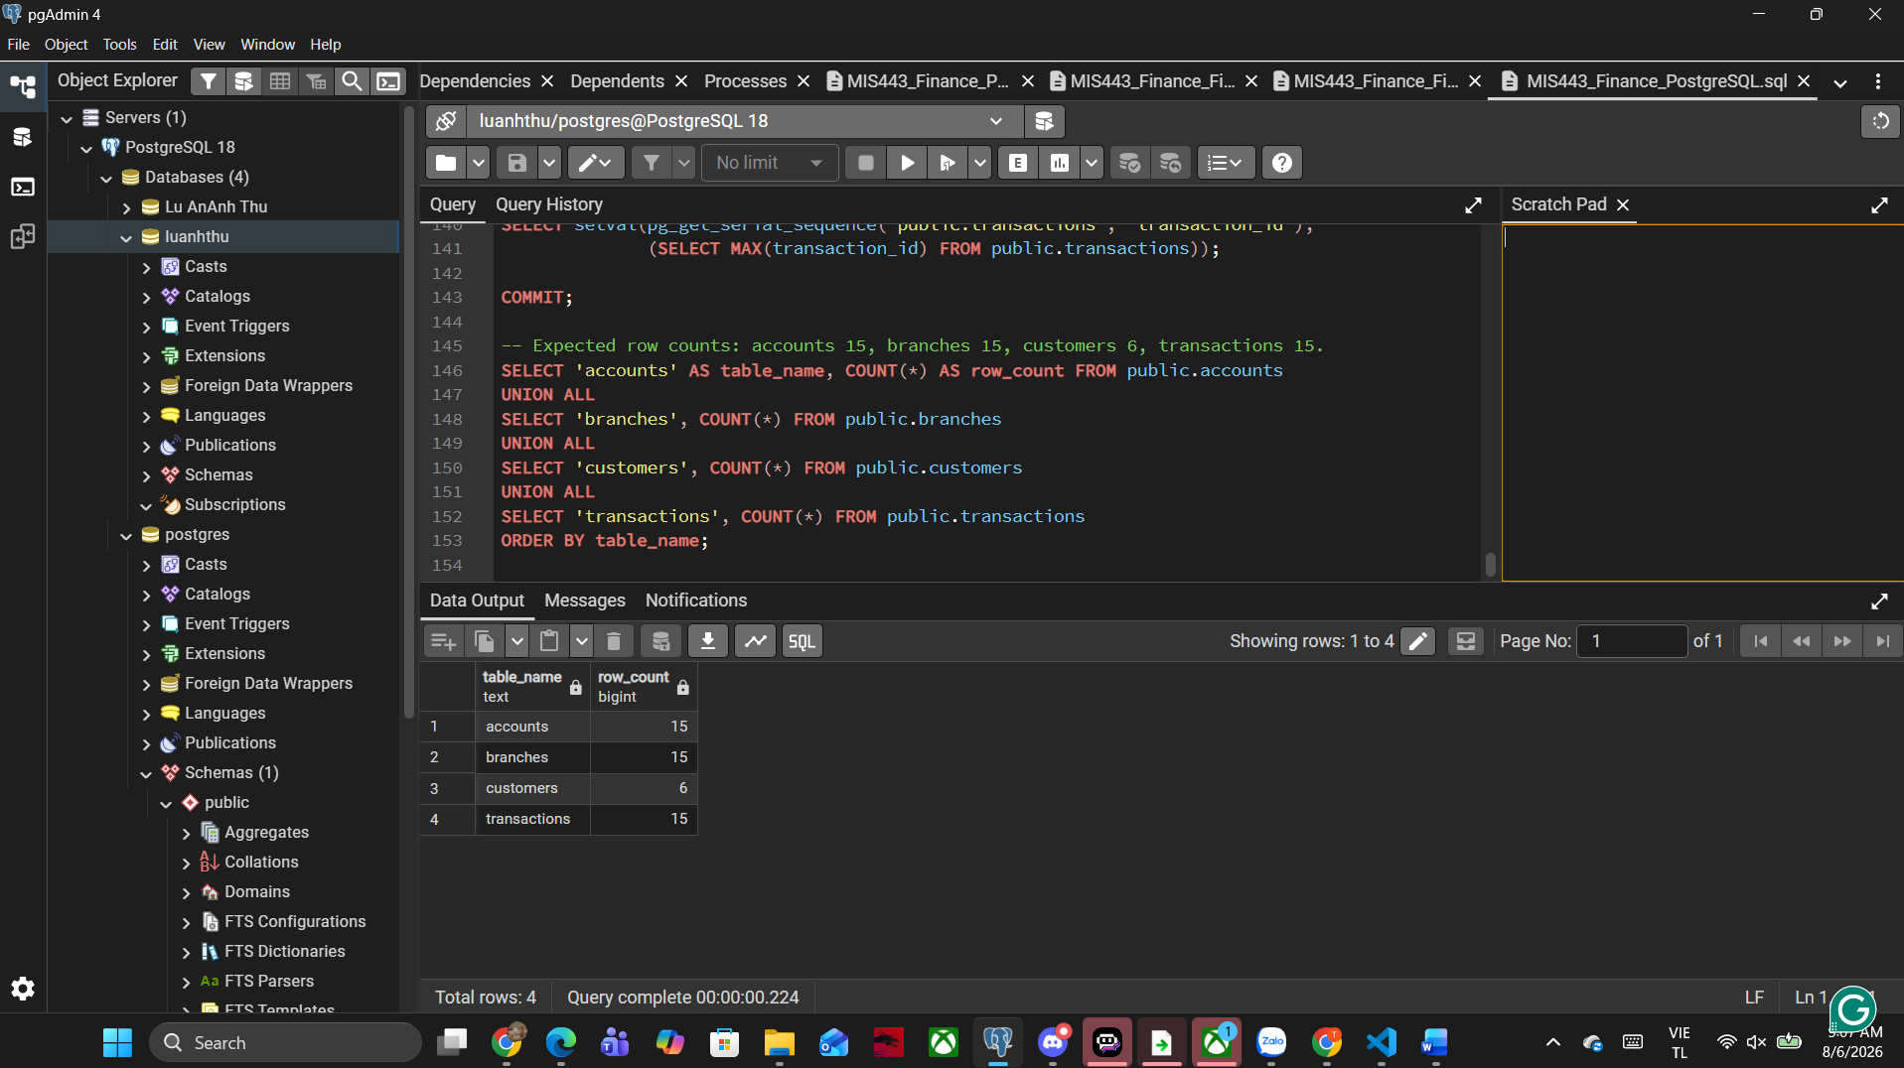

Question 2 – Customer and Account Overview (10 marks)
- The Customer Service Manager needs a contact list of customers living in New York. Display customer_id, the customer’s full name as full_name, and city. Sort by customer_id. (5 marks)
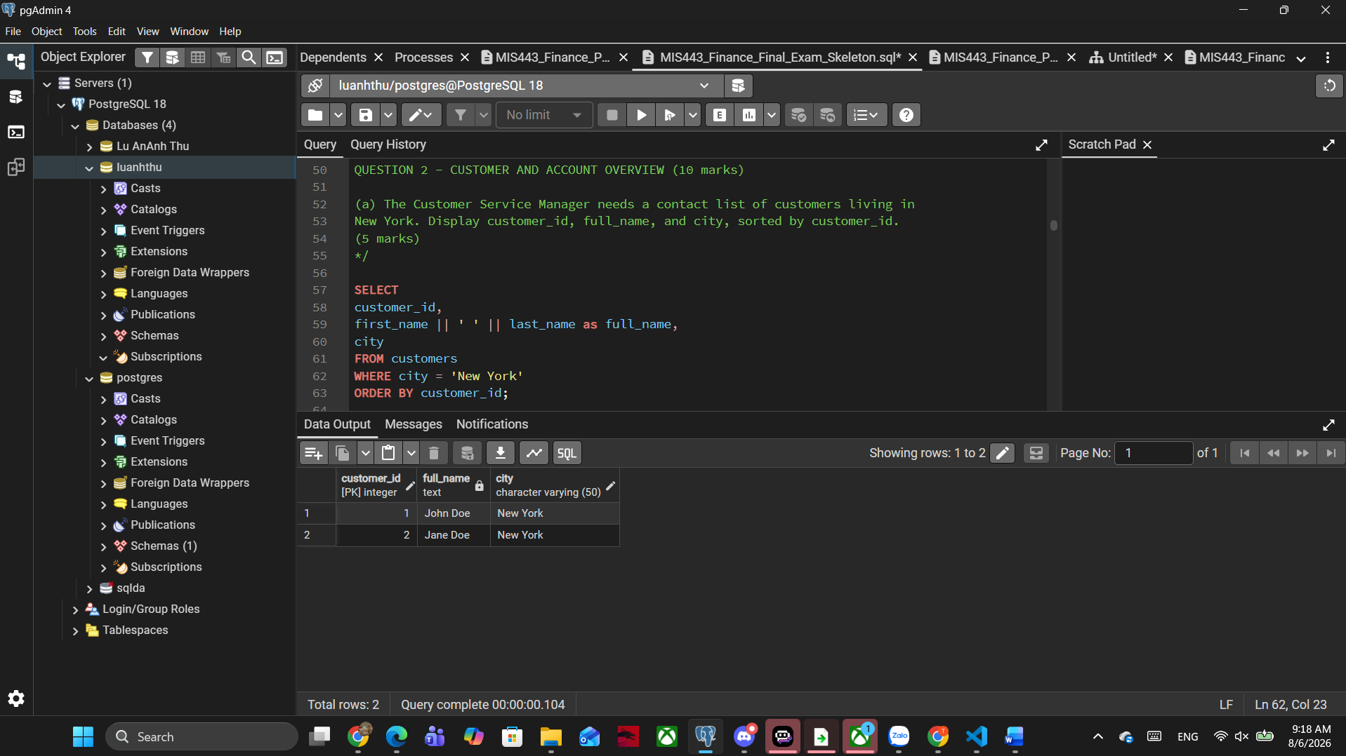
- Management needs to confirm the size of the account portfolio. Calculate the total number of accounts and name the result total_accounts. (5 marks)
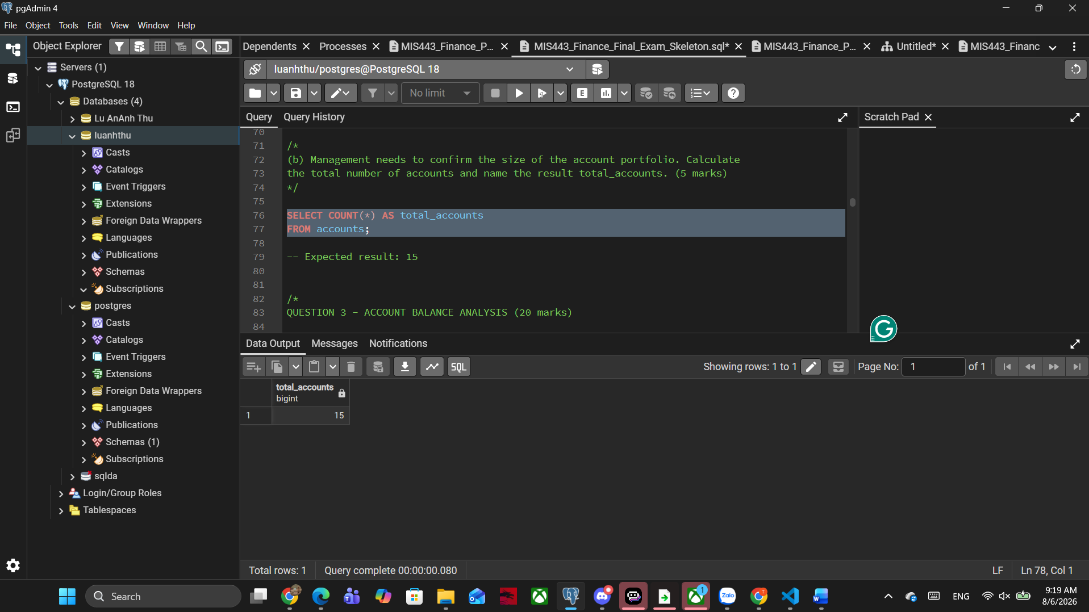

Question 3 – Account Balance Analysis (20 marks)
- The Finance Manager wants to monitor funds held in Checking accounts. Calculate their total balance and name the result total_checking_balance. (10 marks)
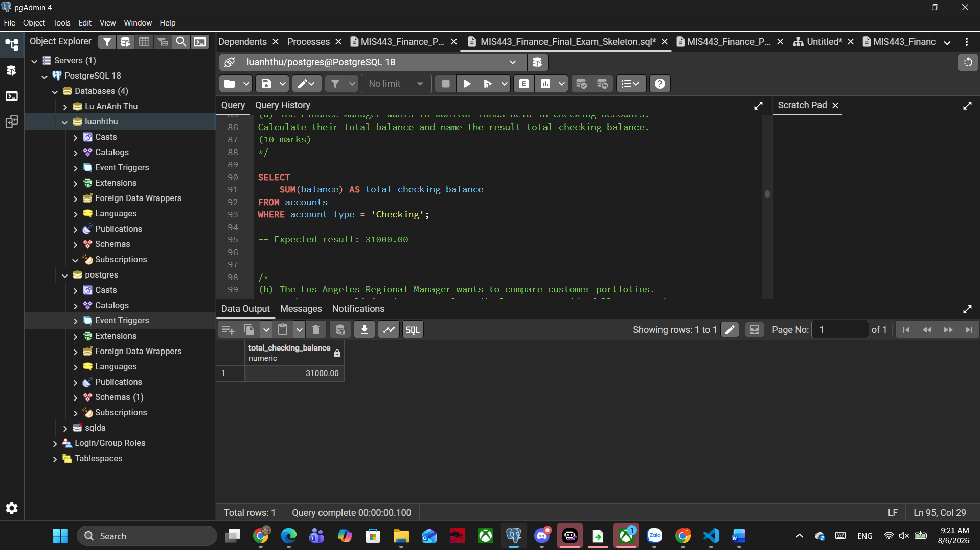
- For each customer living in Los Angeles, display customer_id, full_name, and total_balance across all account types. Sort by total_balance from highest to lowest. (10 marks)
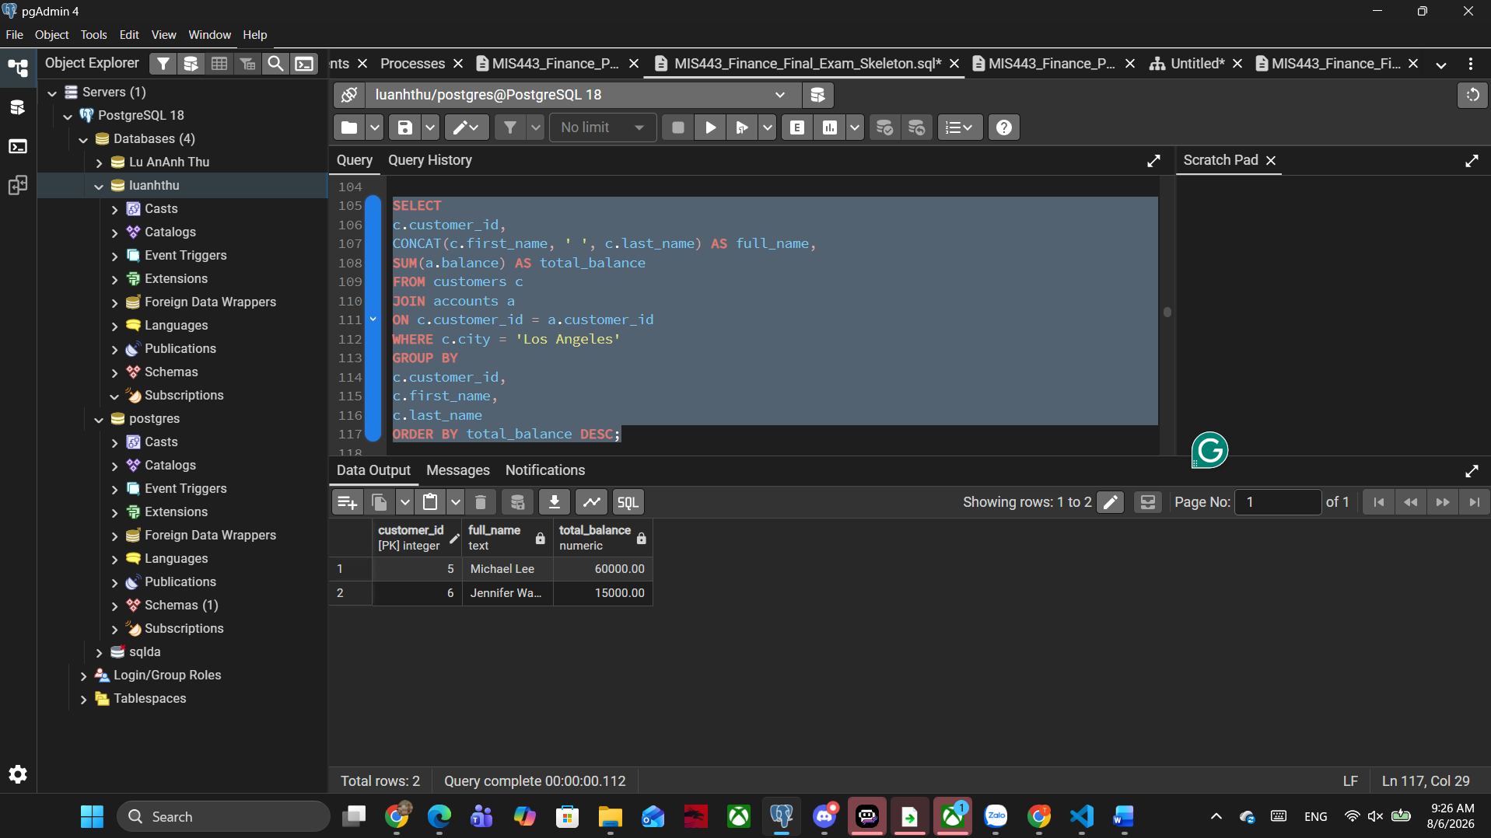

Question 4 – Branch and Customer Portfolio Analysis (20 marks)
- Identify the branch with the highest average account balance. Display branch_id, branch_name, city, and average_balance. Round to two decimal places and include ties. (10 marks)
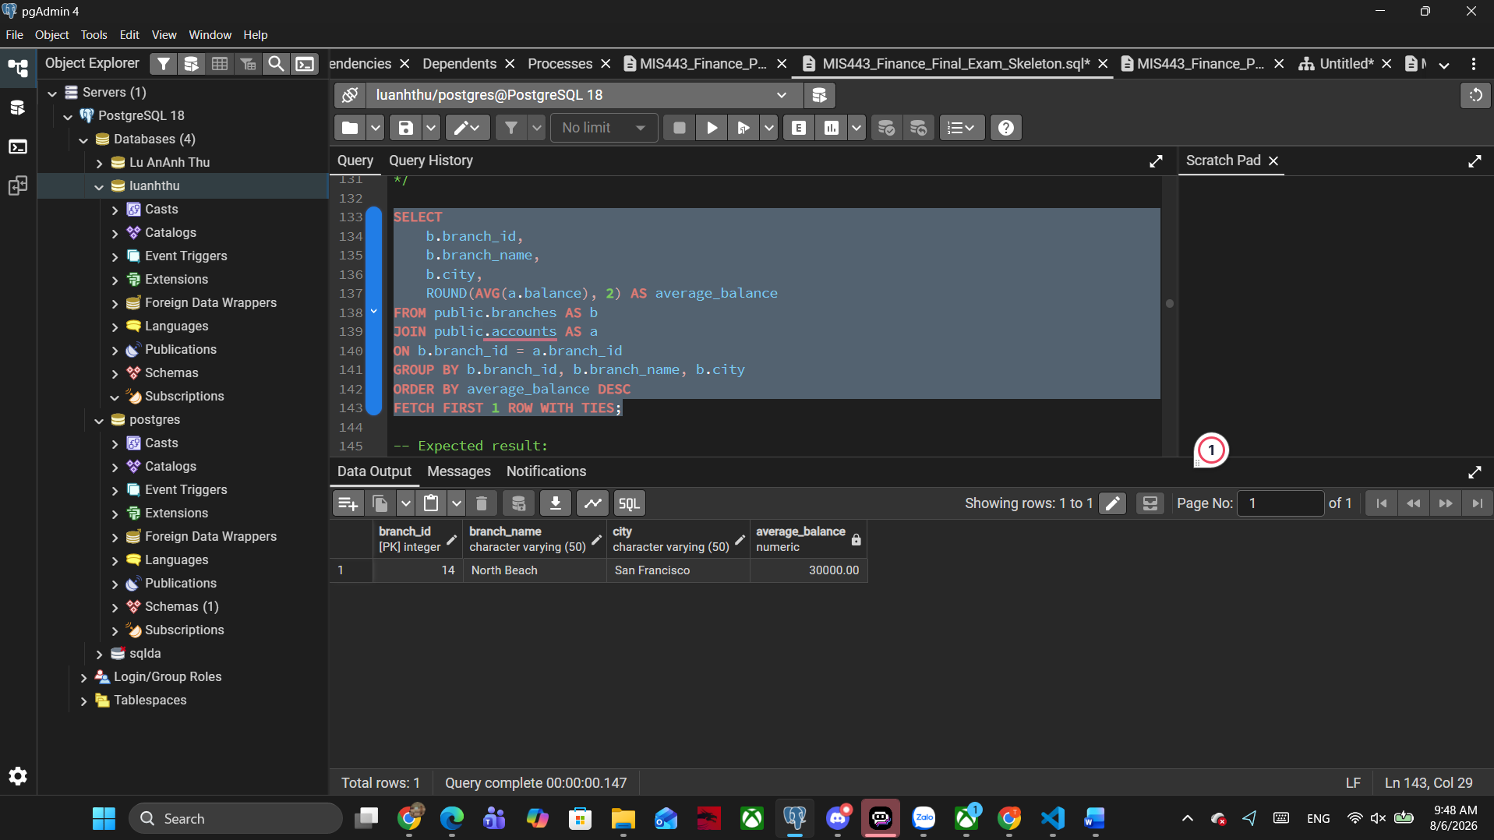
- Identify the customer who owns the single account with the highest current balance. Display customer_id, full_name, account_id, account_type, and balance. Include ties. (10 marks)
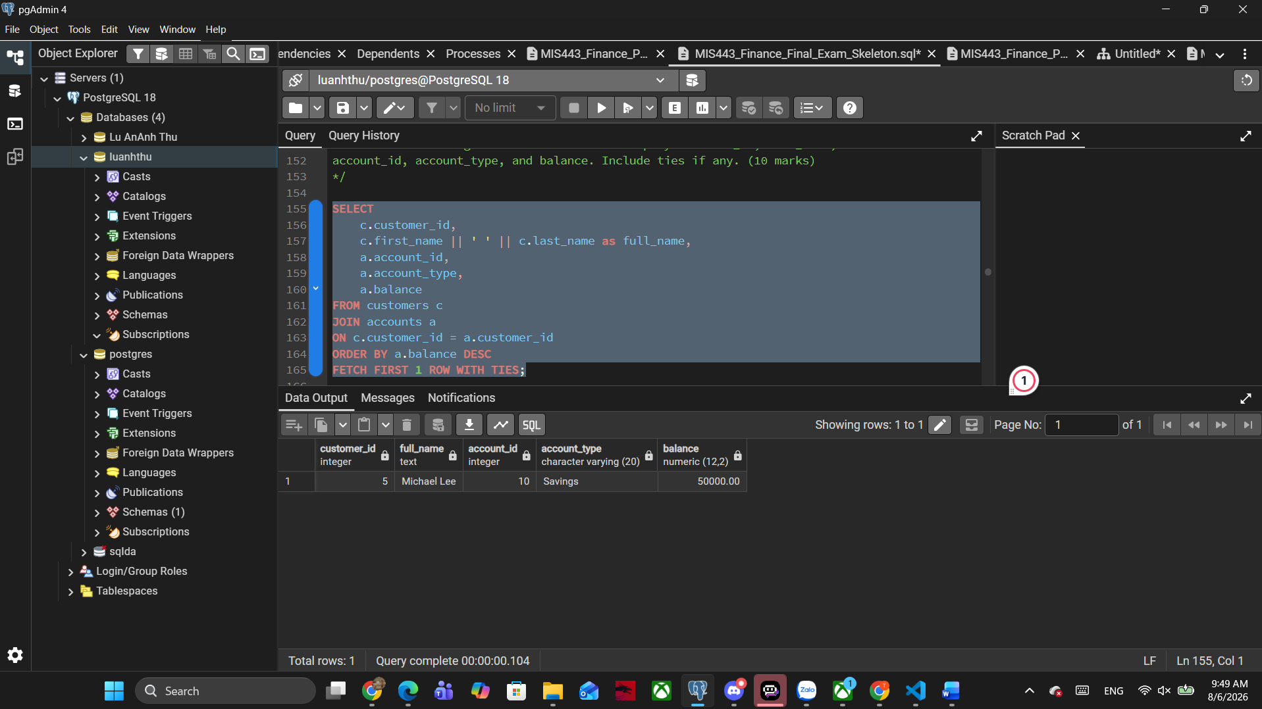

Question 5 – Customer Value and Activity (20 marks)
- Identify the most active customers based on the total number of transactions across all their accounts. Display customer_id, full_name, and total_transactions. Include ties. (10 marks)
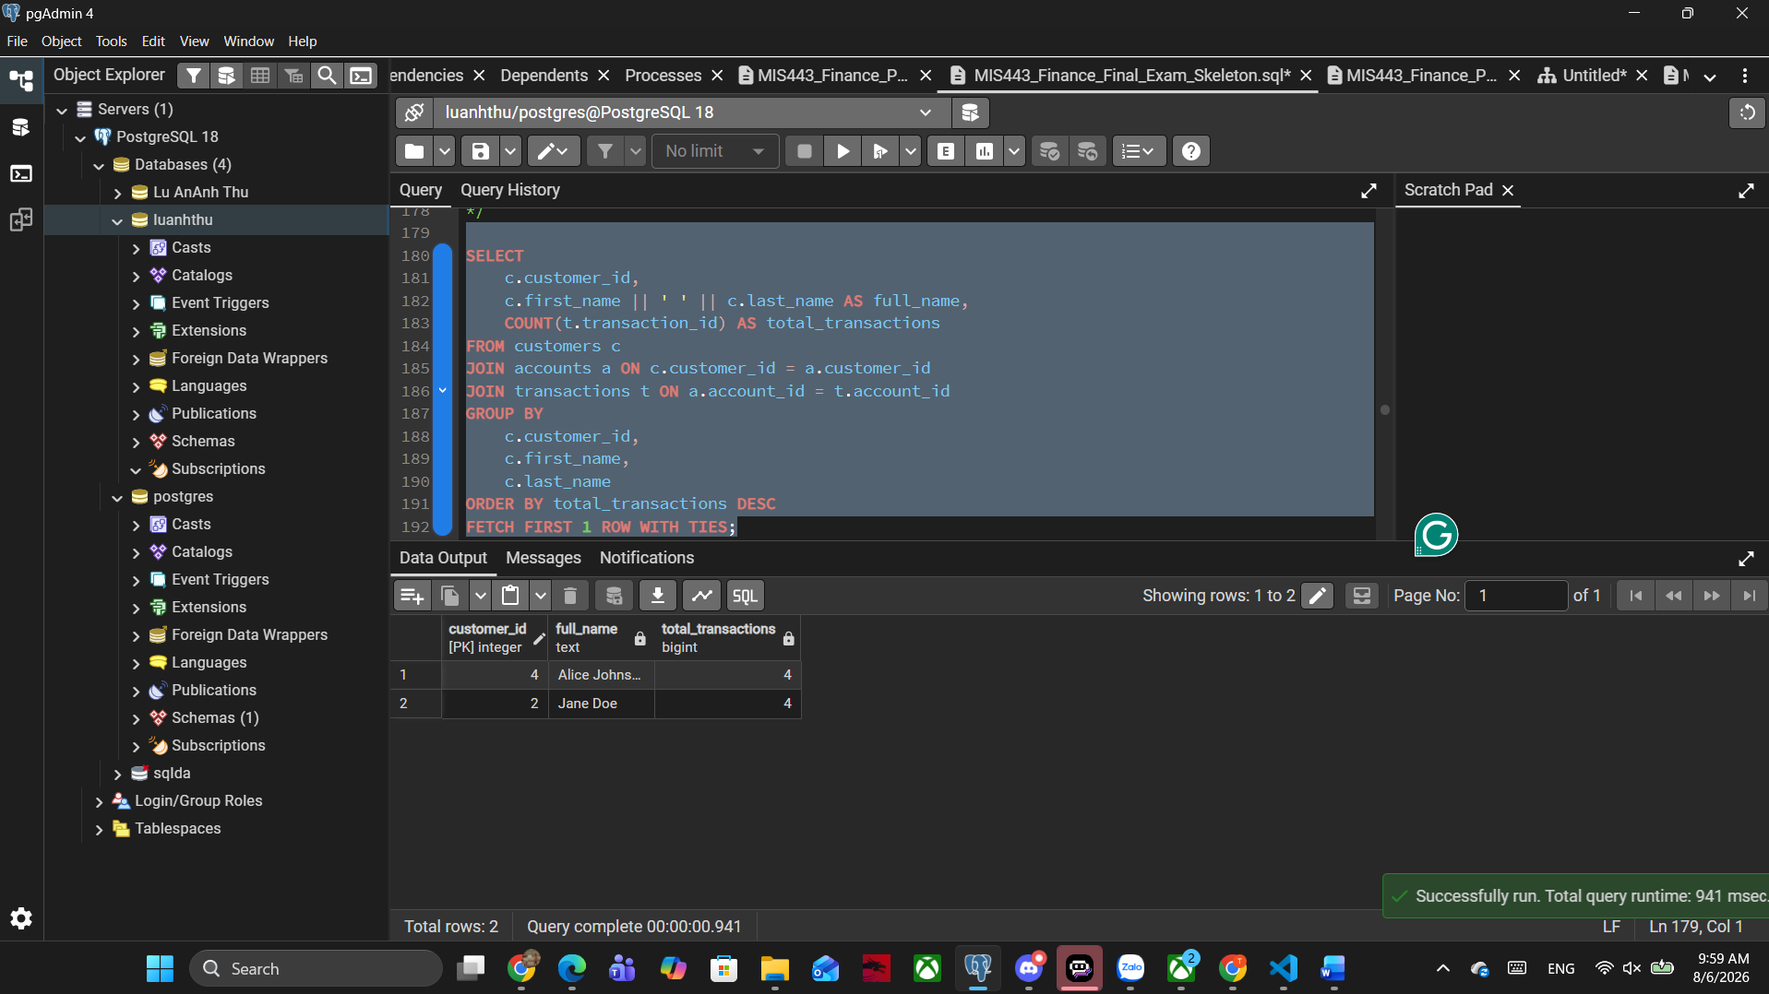
- Identify the customer with the highest combined balance across Checking and Savings accounts. Exclude Credit Card accounts. Display customer_id, full_name, and total_deposit_balance. Include ties. (10 marks)
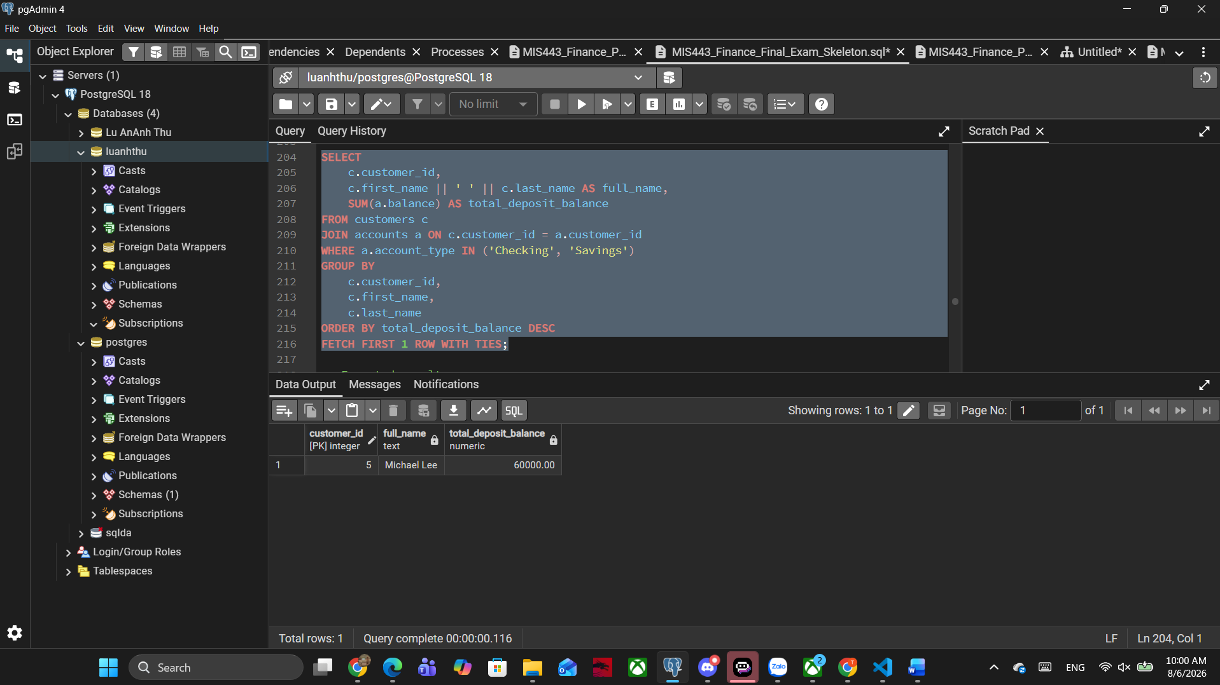

Question 6 – Advanced Finance Analysis (20 marks)
(a) Identify the branch with the highest total balance across all account types. Display branch_id, branch_name, and total_balance. Include ties. (10 marks)
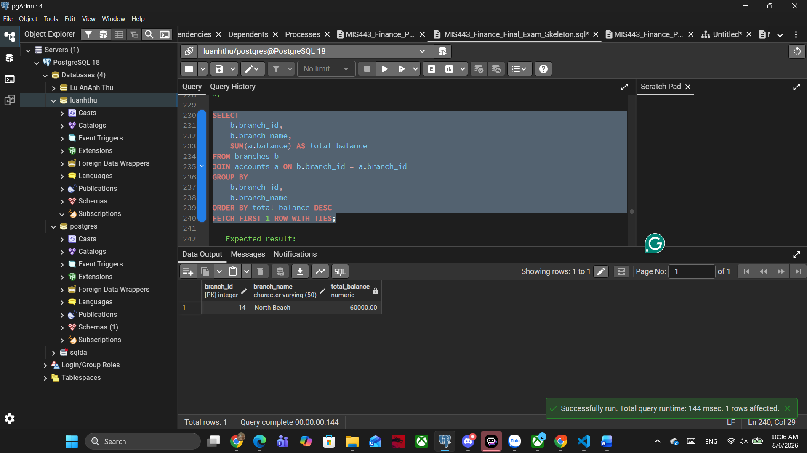
(b) Rank all customers by total balance across all account types. Equal totals must receive the same rank without gaps. Display customer_id, full_name, total_balance, and balance_rank. Do not use a CTE. (5 marks)
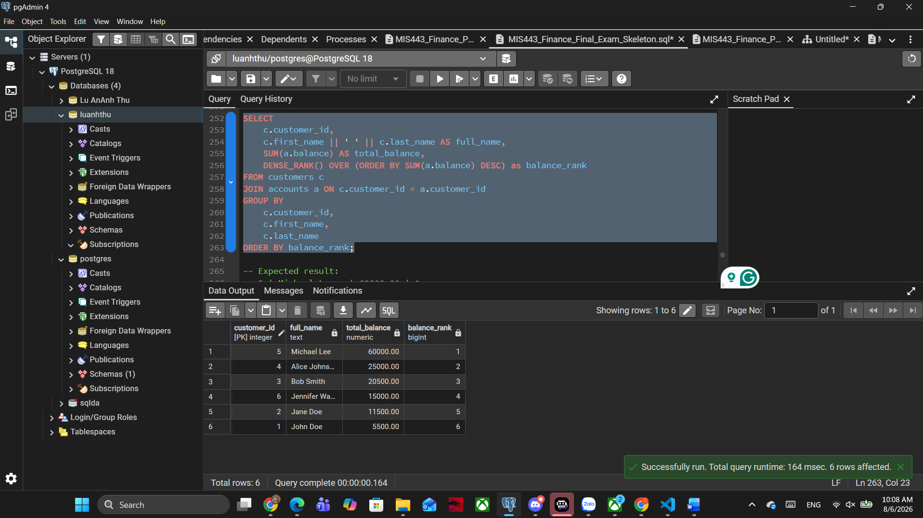
(c) Use a CTE to calculate the total number of transactions for every branch, including branches with no transactions. Return the branch or branches with the highest total. Display branch_id, branch_name, and total_transactions. (5 marks)

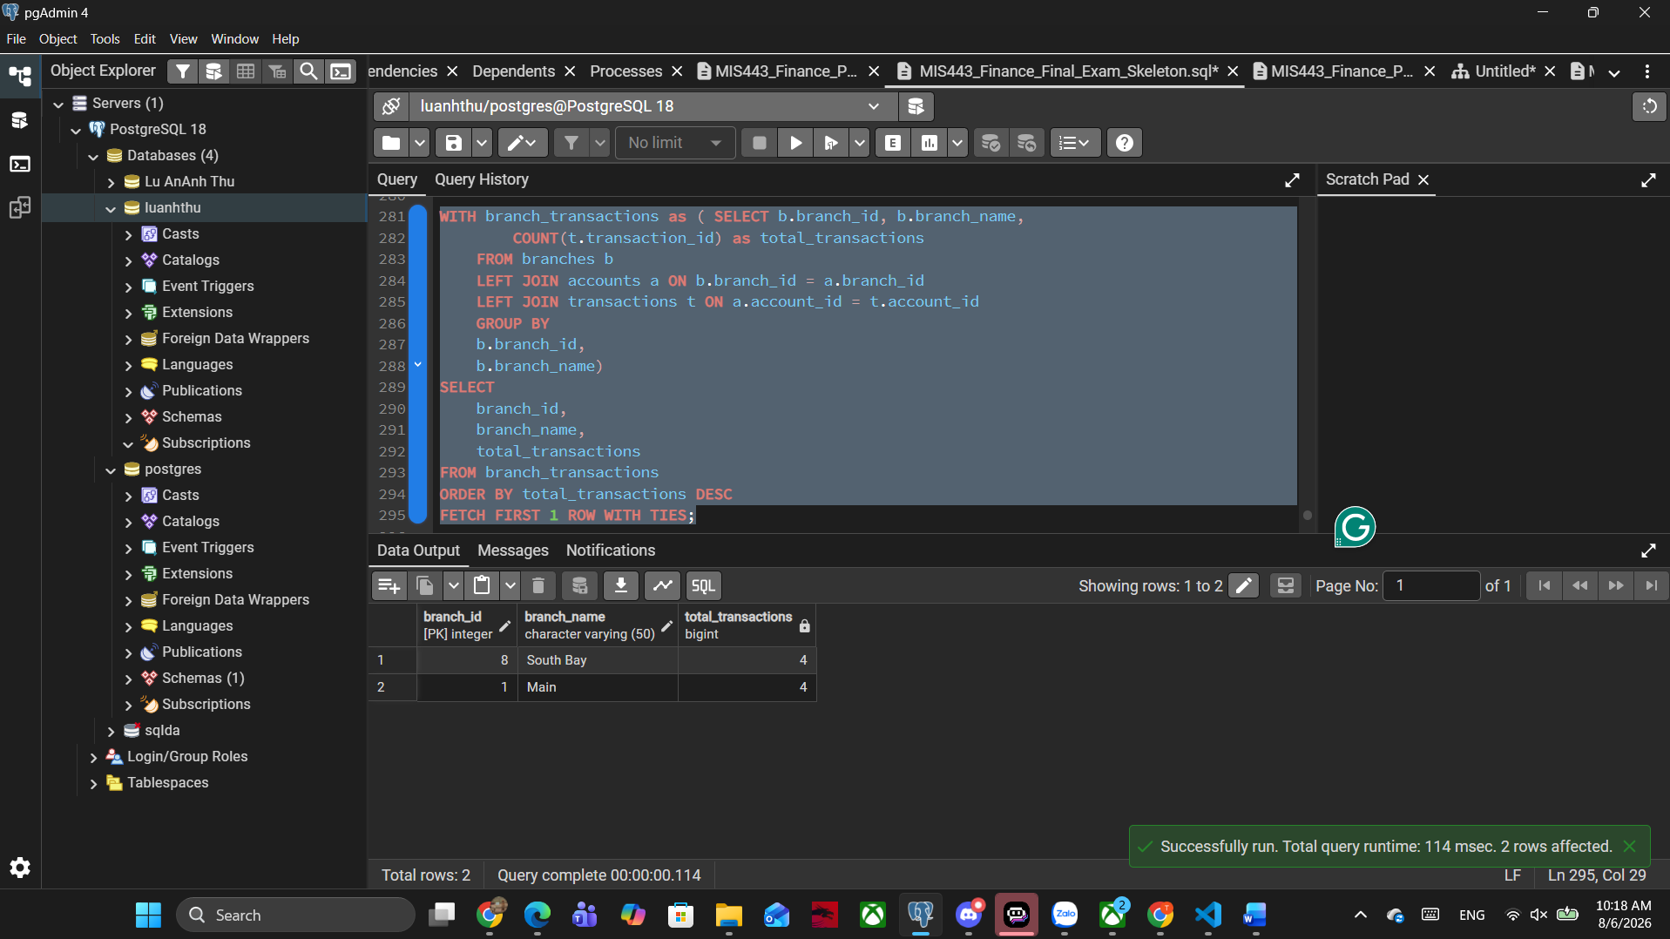

Mark Distribution
Question | Marks
Question 1 | 10
Question 2 | 10
Question 3 | 20
Question 4 | 20
Question 5 | 20
Question 6 | 20
END OF EXAMINATION

